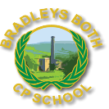

Bradleys Both Community Primary School
Safeguarding Information
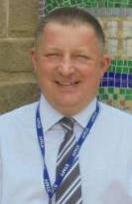 | Mr Barry Rogers  DSL  Designated Safeguarding Lead  “Our Safeguarding Lifeguard’
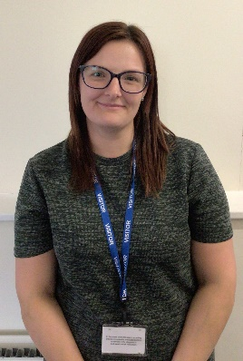 | Mrs Rachel Spensley  DDSL  Deputy Designated Safeguarding Lead
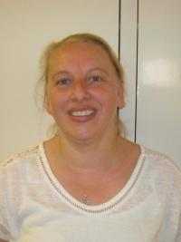 | Mrs Julie Midgley  Pastoral  Teaching Assistant  “Mrs Midgley loves to listen to you”
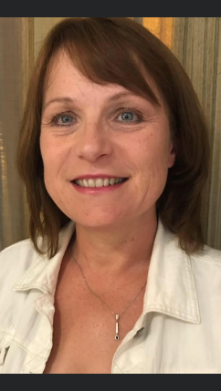  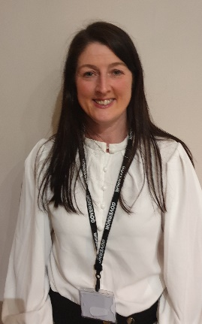 | Mrs Becky Stapleton  &  Mrs Carol Roertson  Safeguarding Governors
You can contact our Safeguarding staff by speaking to the School Office, emailing admin@bradleysboth.n-yorks.sch.uk or telephoning 01535 633116
‘L I F E Learn, Inspire, Flourish, Engage’

